Travlr Module 6 Development and Testing

Initial trip listing screenshot
The first Angular listing shoId the three starting trips. The added trip appears in a later screenshot.
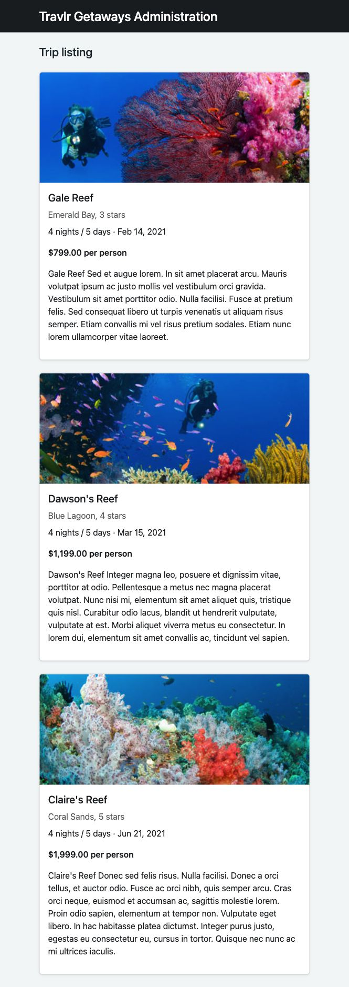

Express Ibsite startup
I ran npm start and the home page loaded. The trips API failed at first because MongoDB was not running; I fixed that in the next step.
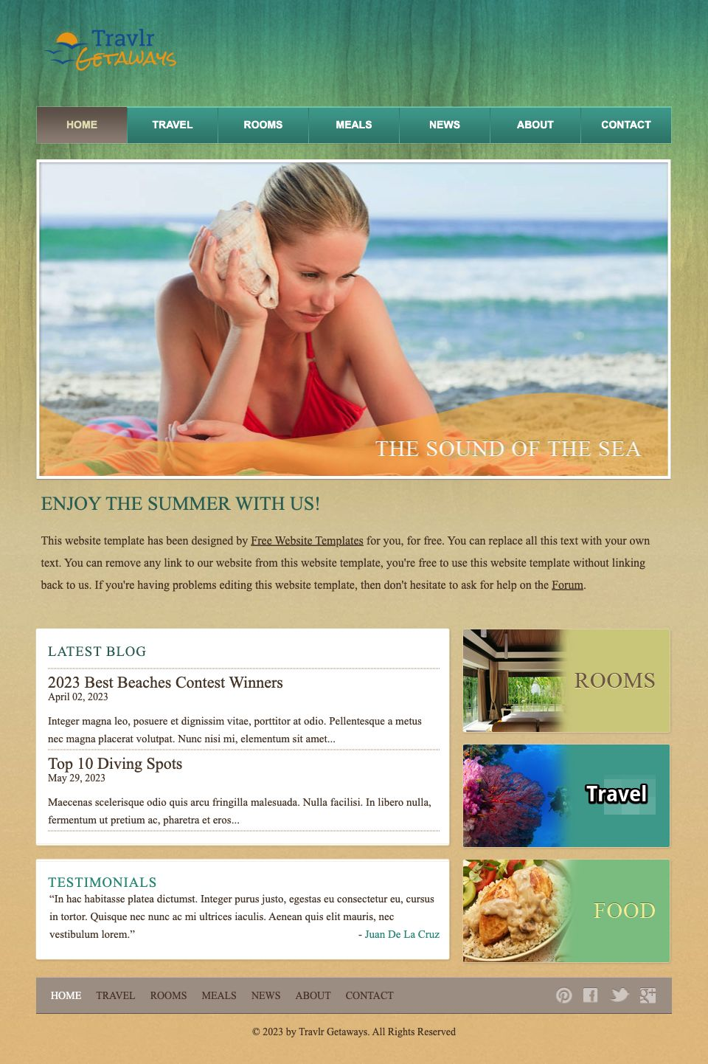

Database backed Travel page
Next started MongoDB and added the three starting trips to the empty database. After restarting Express, both the API and Travel page returned 200. I kept using Node 20 for Angular.
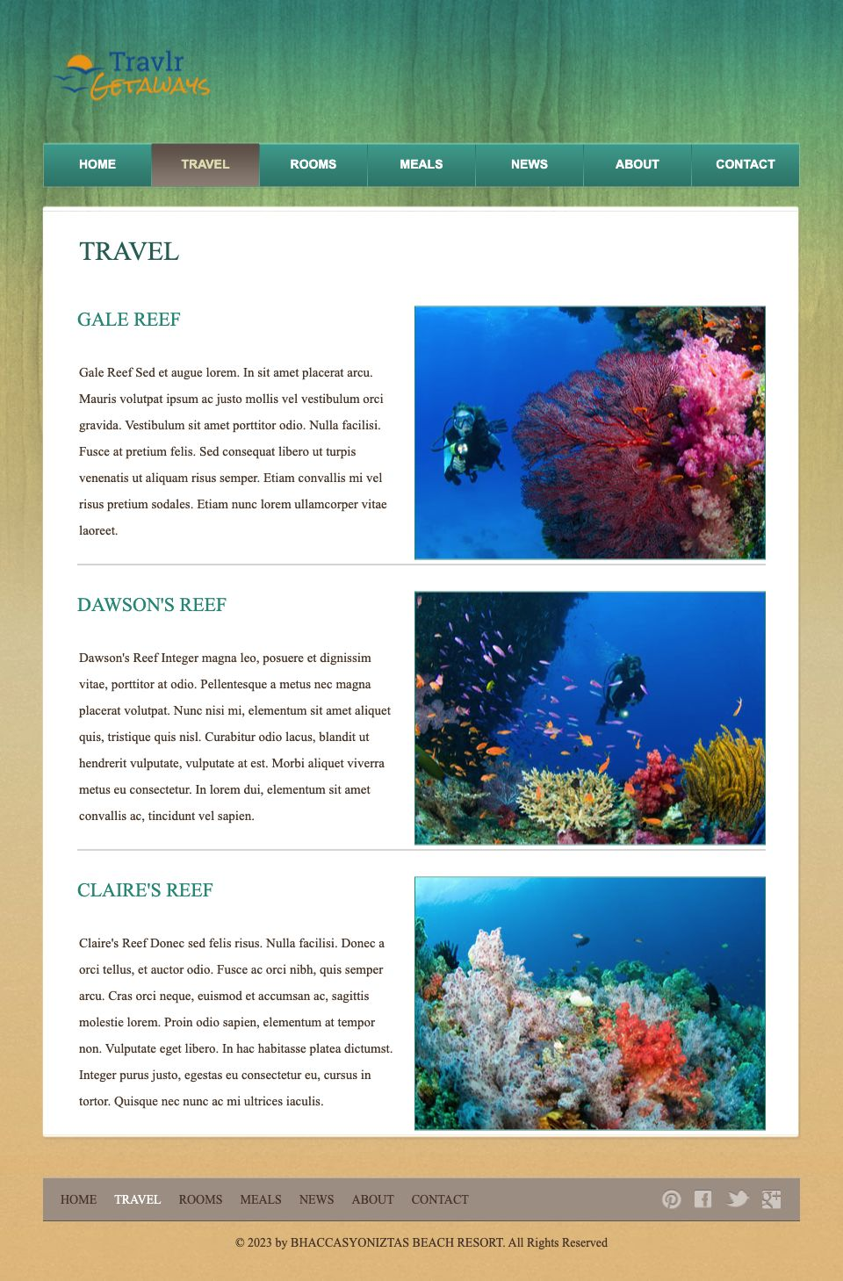

Angular API listing verified
I then connected the listing to TripDataService and enabled HTTP requests and CORS. The build passed, the API returned 200, and all three trips loaded without browser errors. The CORS preflight returned 204.

Reusable trip cards verified
I moved the card layout into a reusable Trip Card component and added the Trip model. The build passed and all three cards still displayed correctly.
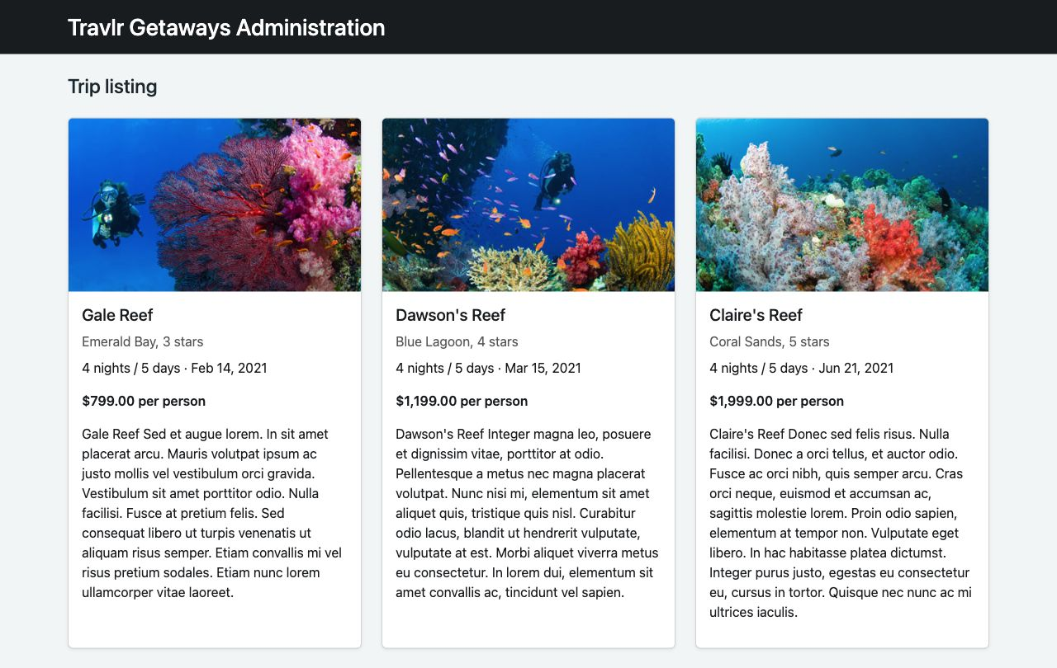

Postman GET all trips
I requested all trips in Postman without signing in. The API returned 200 with the trip list, and all three checks passed.
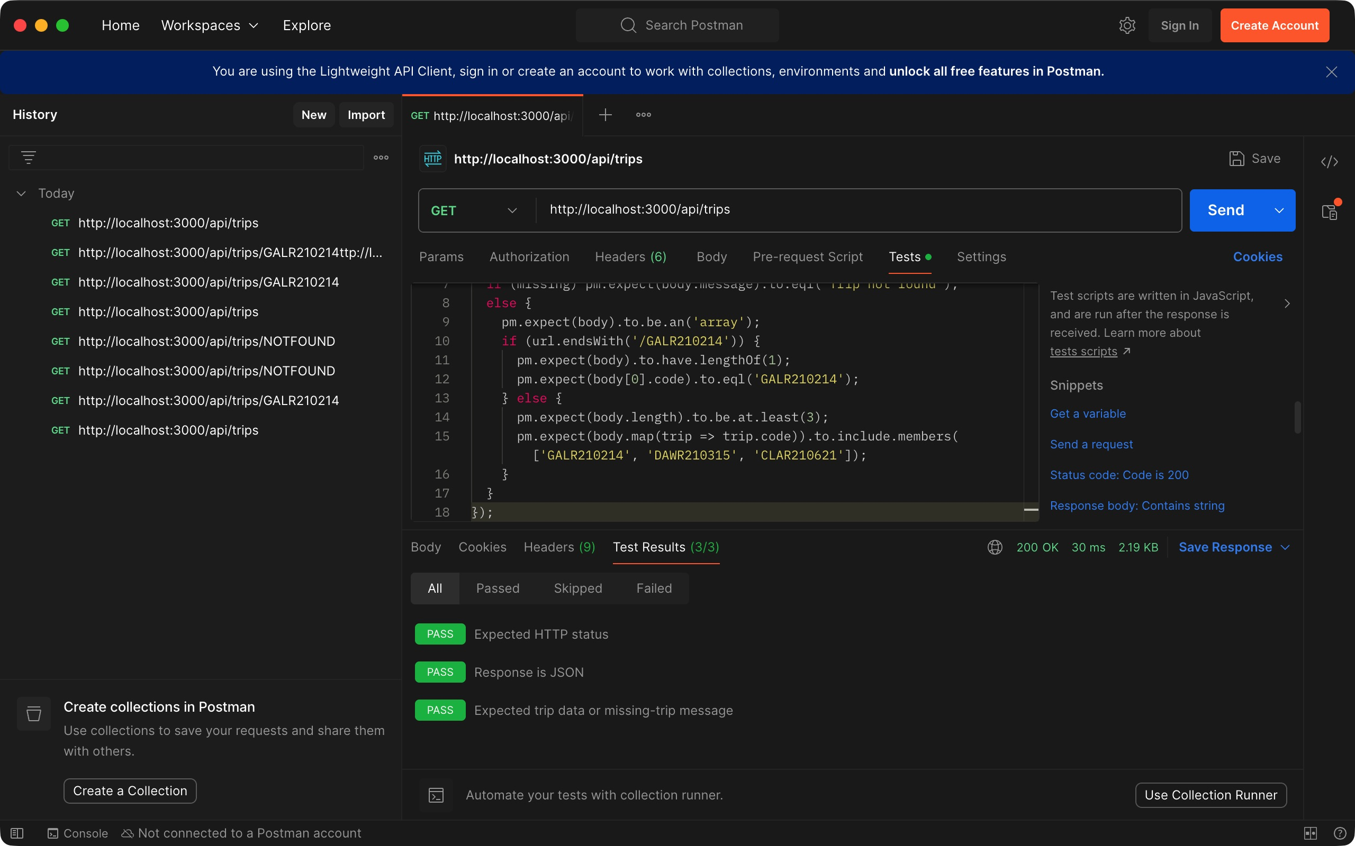

Postman GET one trip
I requested Gale Reef by its trip code. The API returned 200 with the correct trip, and all three Postman checks passed.
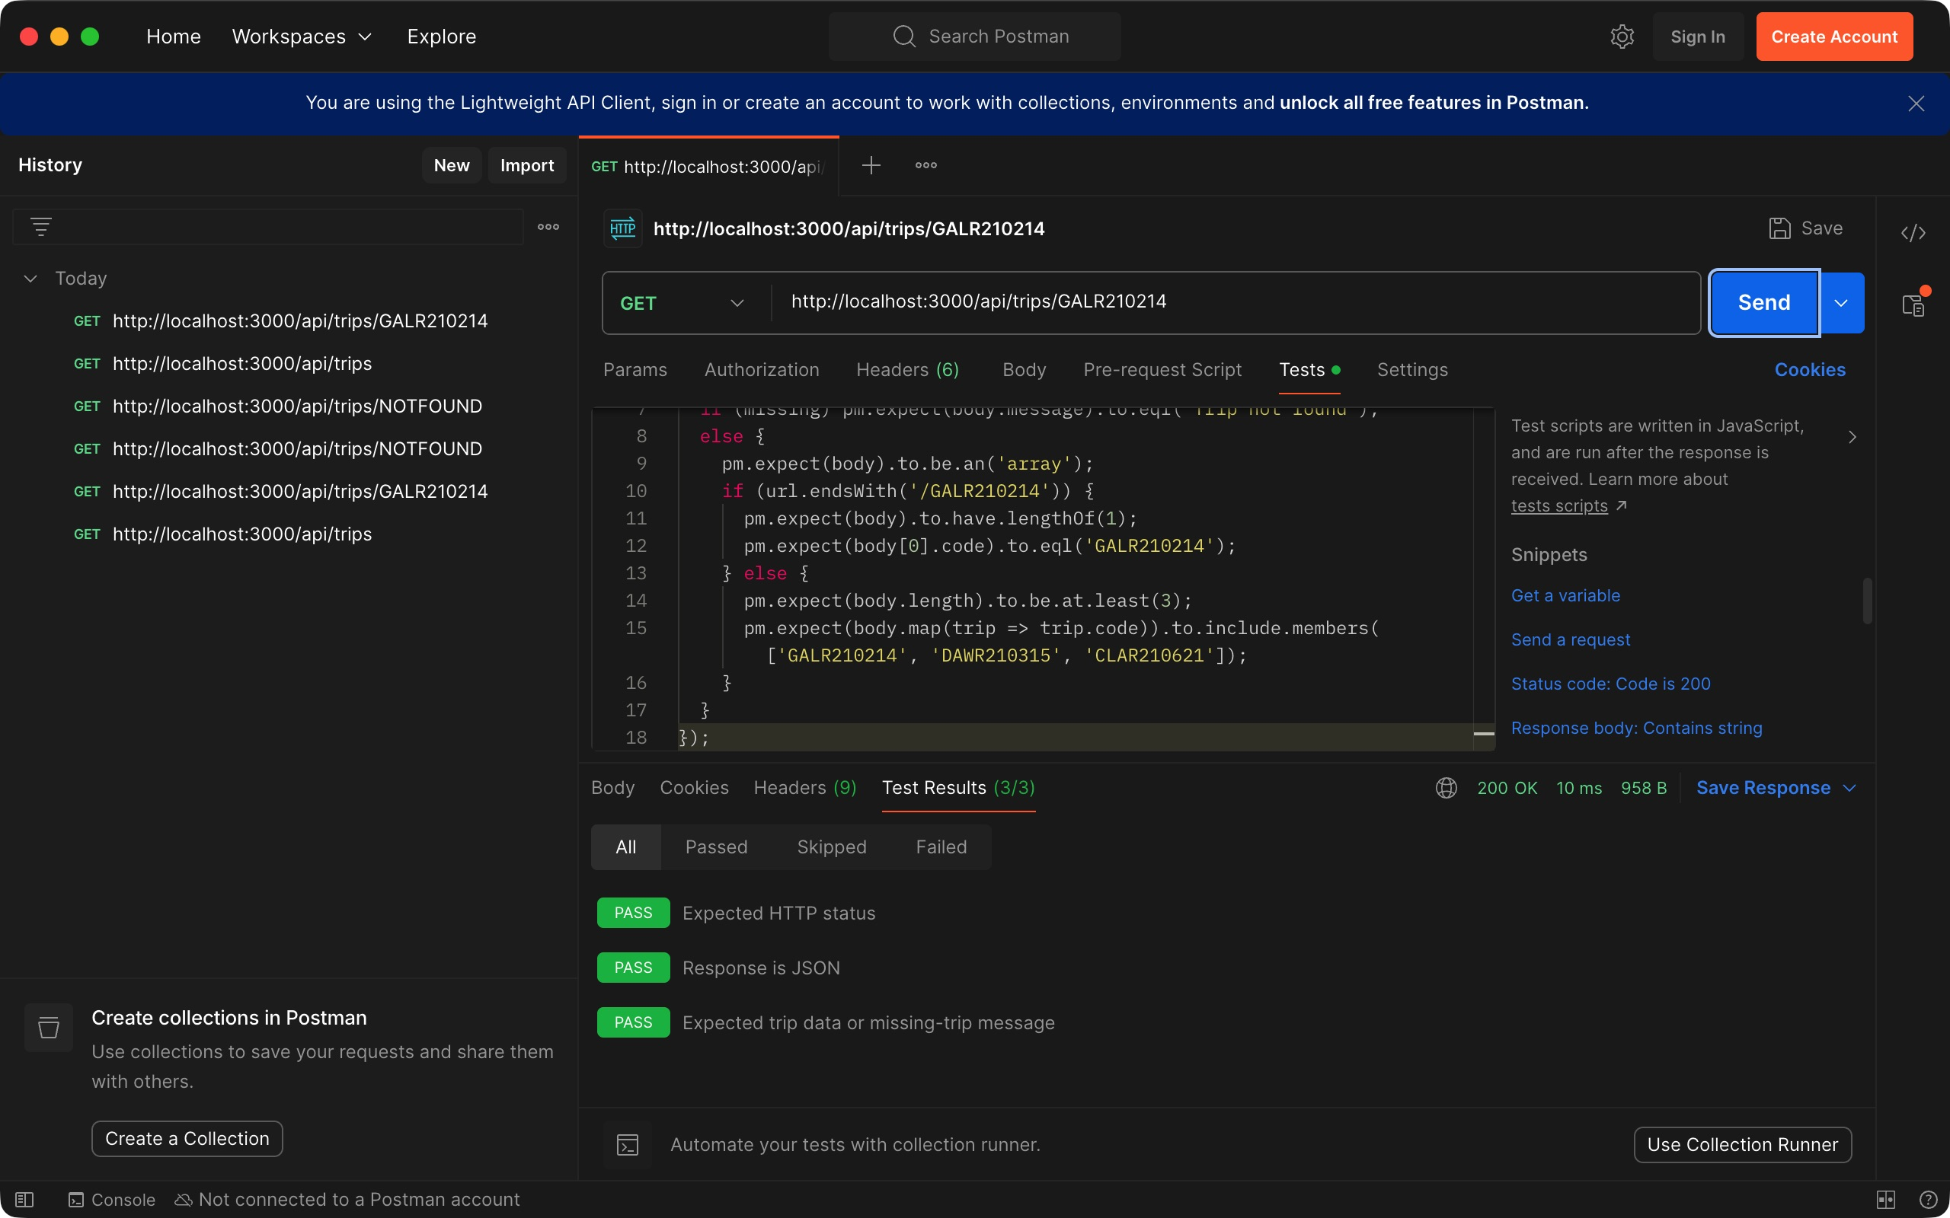

Postman missing trip
I requested a trip code that does not exist. The API returned 404 with “Trip not found.” All three Postman checks passed.
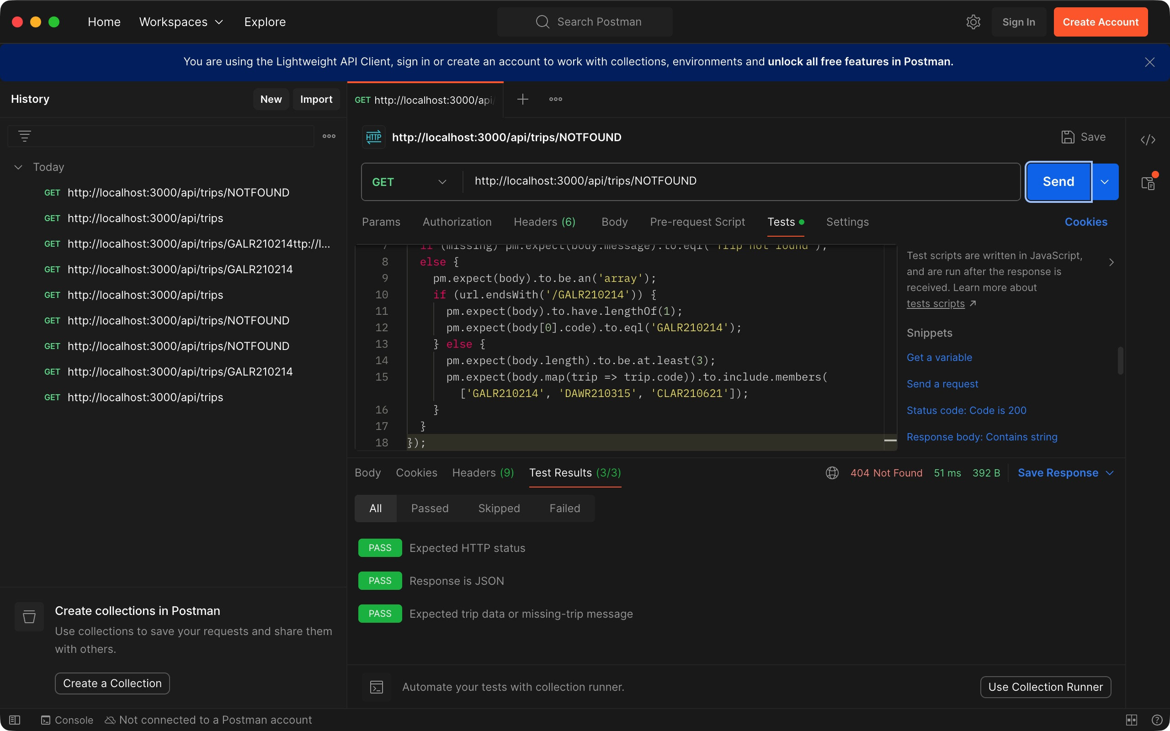

Add Trip form validation
I added routing and the Add Trip form. Saving an empty form shoId validation messages and did not create a trip.
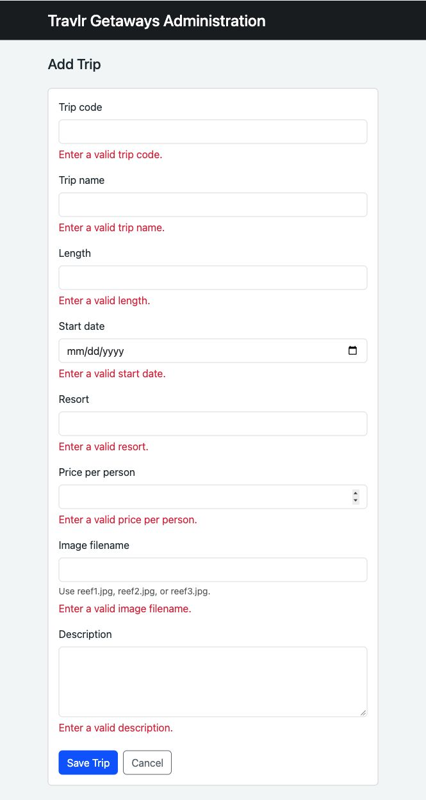

Add Trip form completed
I filled in all eight fields for Coral Cove Escape, starting June 15, 2027, at $1,499 per person. Saving sends the trip to the API.
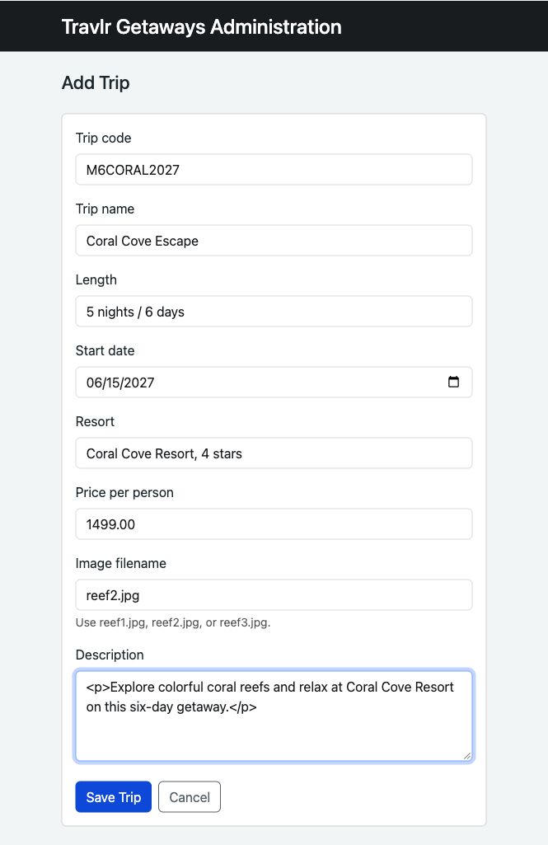

Additional trip card listing
Coral Cove Escape appeared in the listing and MongoDB after saving.
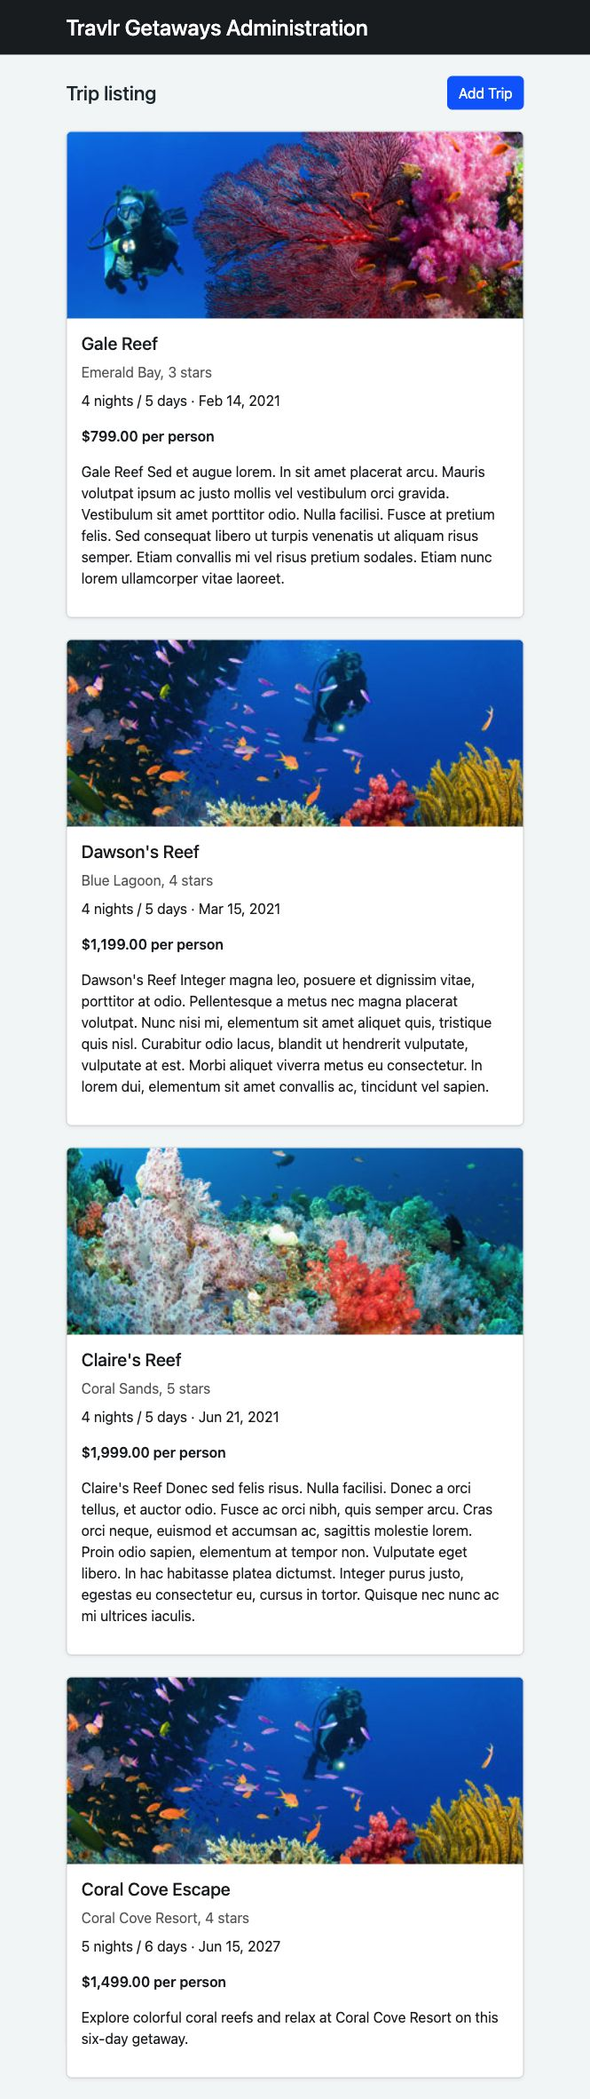

Additional trip on customer Ibsite
Coral Cove Escape also appeared on the customer Travel page, confirming that both sites read the saved trip.
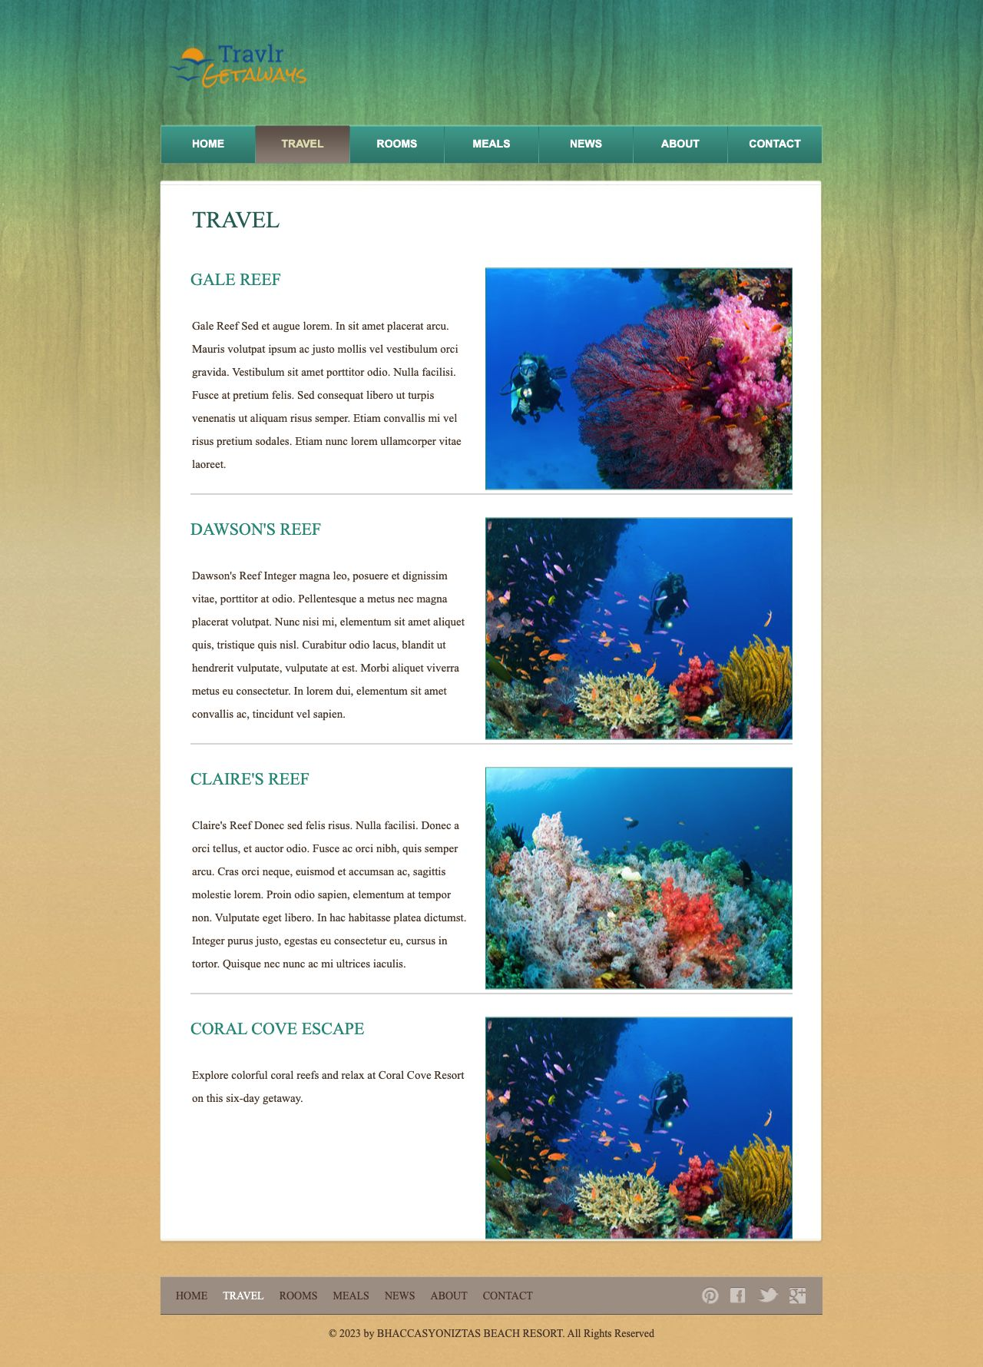

Postman successful POST
I sent a complete trip in Postman. The API returned 201 Created, and all three checks passed. I kept this temporary trip for later update and delete tests.
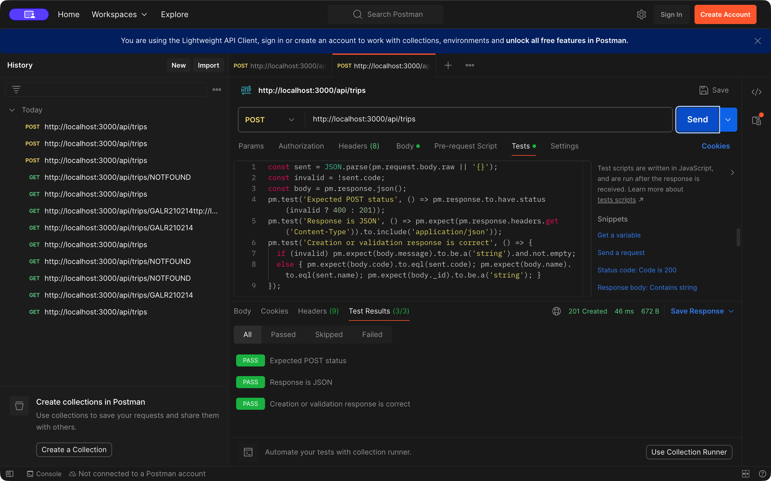

Postman invalid POST
I sent an empty trip in Postman. The API returned 400 with a validation message, and all three checks passed. No empty trip was saved.
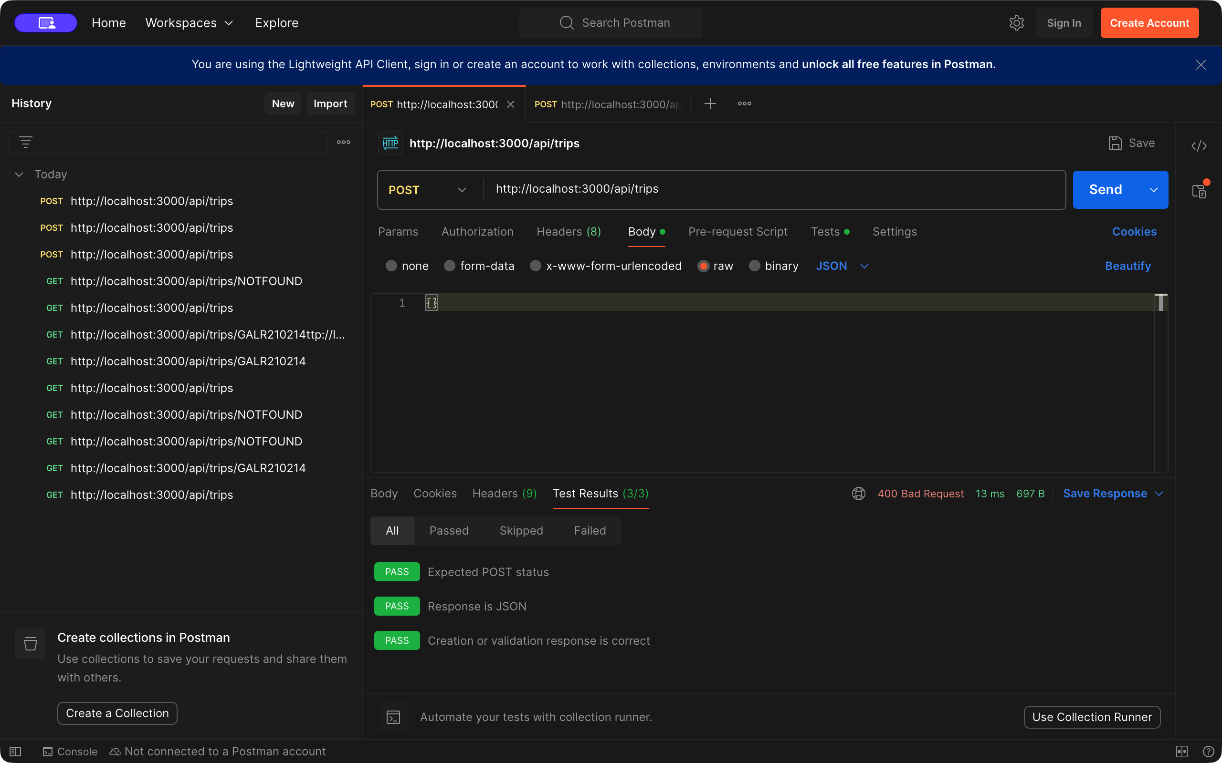

Edit Trip form loaded
I added an Edit Trip link to each card. The form loaded all eight fields for Coral Cove Escape and kept its trip code fixed.
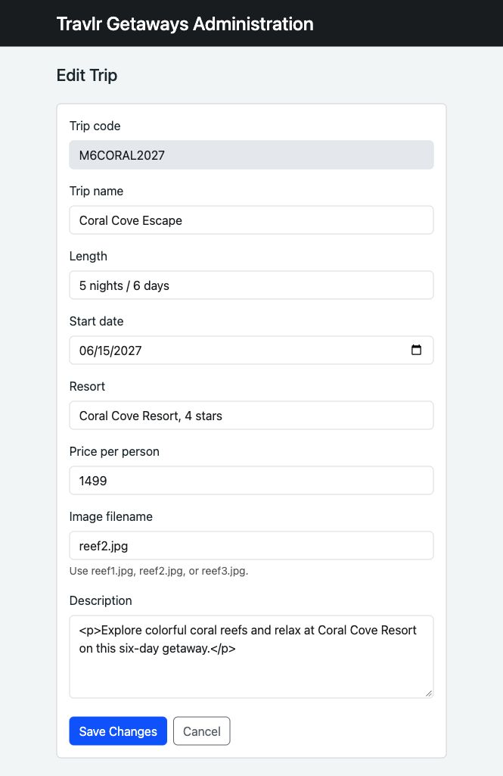

Edit Trip form changed
I changed the name to Coral Cove Escape Deluxe and raised the price from $1,499 to $1,599. This screenshot shows the changes before saving.
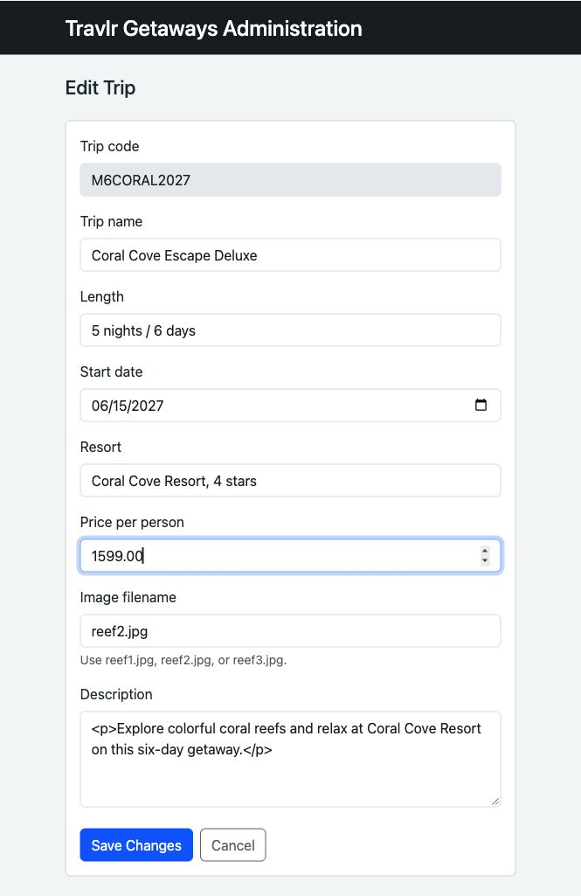

Update saved in Angular
Saving returned us to the listing with a success message. The new name and price Ire saved in MongoDB. The build and browser checks passed. Separate HTTP tests returned 200 for a valid update, 400 for invalid data, and 404 for a missing trip.
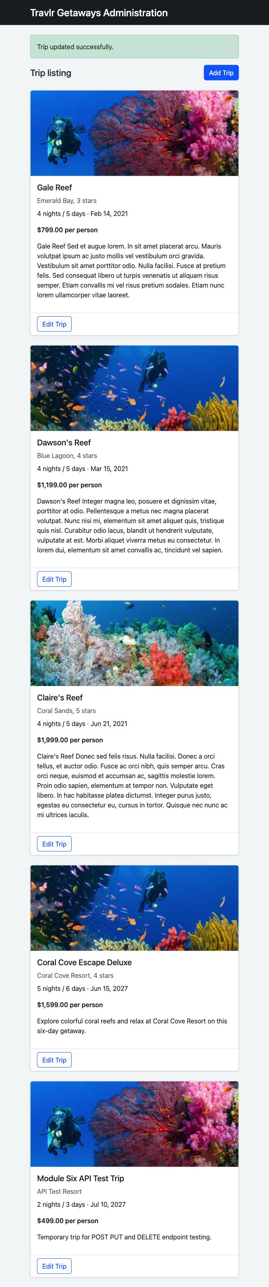

Update shown on customer Ibsite
The customer Travel page also shoId Coral Cove Escape Deluxe, confirming that the update was saved and shared across both sites.


